Chomsky's Three Models of Language

Who is Chomsky
# Source: AI Source: Provided by: [Data Path: Persons Table -> ID Column: 1, Name_En Column: Motasem Essam] -> From: [Chatgpt (GPT‑5 Mini)] on [10/23/2025]
Chomsky usually refers to Noam Chomsky, one of the most influential figures in linguistics, cognitive science, and philosophy.
Here’s a quick overview 👇
🧠 Who is Noam Chomsky?
- Full name: Avram Noam Chomsky
- Born: 1928, in the United States
- Fields: Linguistics, Cognitive Science, Philosophy, Political Activism

🗣️ In Linguistics
Chomsky revolutionized the field in the 1950s by introducing Generative Grammar, which studies the mental structures humans use to produce and understand language.
Key Ideas:
- Universal Grammar (UG):
The idea that all human languages share a common structural foundation—an innate set of grammatical principles in the human mind.
- Competence vs. Performance:
  - Competence = what a speaker knows about their language (internal grammar).
  - Performance = how a speaker uses language in real situations (which can include mistakes, pauses, etc.).
- Language Acquisition Device (LAD):
A theoretical mechanism in the brain that allows children to acquire language naturally from limited input.

🧩 In Cognitive Science
Chomsky helped found the cognitive revolution, rejecting behaviorism (which saw language as learned behavior) and promoting the idea that the mind has innate structures for language and thought.

🗳️ In Politics
He’s also well-known as a political activist and critic of U.S. foreign policy, capitalism, and media manipulation (e.g., Manufacturing Consent).

Chomsky’s Three Models of Language
# Source: AI Source: Provided by: [Data Path: Persons Table -> ID Column: 1, Name_En Column: Motasem Essam] -> From: [Chatgpt (GPT‑5 Mini)] on [10/23/2025]
Let’s break down Chomsky’s three key models of language carefully and clearly. These are foundational concepts in modern linguistics.

1️⃣ Linguistic Competence
# Source: AI Source: Provided by: [Data Path: Persons Table -> ID Column: 1, Name_En Column: Motasem Essam] -> From: [Chatgpt (GPT‑5 Mini)] on [10/23/2025]
Definition:
- Refers to a speaker’s internal knowledge of their language—the mental system of rules that allows them to produce and understand sentences.
- It’s idealized: it’s about what a speaker knows, not how they actually speak in real life.
Key Points:
- Focuses on grammar, syntax, and structure of language.
- Example: A native English speaker knows instinctively that “The cat is on the mat” is correct, but “Cat the mat on is” is not.
- It’s like the “mental dictionary + grammar rules” of a person.

2️⃣ Linguistic Performance
# Source: AI Source: Provided by: [Data Path: Persons Table -> ID Column: 1, Name_En Column: Motasem Essam] -> From: [Chatgpt (GPT‑5 Mini)] on [10/23/2025]
Definition:
- Refers to the actual use of language in real situations.
- Performance can be affected by memory limits, distractions, errors, fatigue, etc.
Key Points:
- Focuses on speaking, listening, reading, and writing.
- Example: Someone may know the correct sentence (competence), but while speaking quickly, they might say “The cat on mat is”—this reflects performance, not a lack of competence.
- Performance is observable, competence is mental.

3️⃣ Language Acquisition Model (LAD)
# Source: AI Source: Provided by: [Data Path: Persons Table -> ID Column: 1, Name_En Column: Motasem Essam] -> From: [Chatgpt (GPT‑5 Mini)] on [10/23/2025]
Definition:
- Chomsky proposed the Language Acquisition Device (LAD), an innate mechanism in the human brain that allows children to acquire language naturally.
Key Points:
- Explains how children can learn complex grammar rules from limited exposure to language.
- Suggests humans have a universal grammar hardwired in the brain.
- Example: A toddler hears a few sentences in English but can quickly form new sentences they have never heard before.

⚡ Summary Table
# Source: AI Source: Provided by: [Data Path: Persons Table -> ID Column: 1, Name_En Column: Motasem Essam] -> From: [Chatgpt (GPT‑5 Mini)] on [10/23/2025]
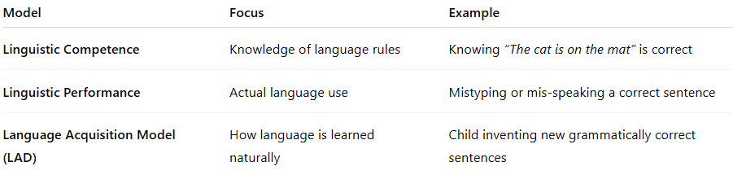
Model | Focus | Example
Linguistic Competence | Knowledge of language rules | Knowing “The cat is on the mat” is correct
Linguistic Performance | Actual language use | Mistyping or mis-speaking a correct sentence
Language Acquisition Model (LAD) | How language is learned naturally | Child inventing new grammatically correct sentences

If you want, I can also draw a simple diagram showing how all three models relate to each other—it makes this much easier to visualize.
Do you want me to do that?

